Project Design Phase-II
Technology Stack (Architecture & Stack)

Date | 02 July 2026
Team ID
Project Name | Sports Hall Booking System using Service Portal (ServiceNow)
Maximum Marks | 4 Marks

Technical Architecture:
The system uses a cloud-native 3-tier architecture built entirely on the ServiceNow Platform. The presentation tier is powered by the ServiceNow Service Portal (AngularJS Widgets), which interfaces via secure REST/Glide APIs with the application tier (Flow Designer, Business Rules, Scheduled Jobs). The data layer utilizes the native, transactional ServiceNow relational database architecture hosted on cloud infrastructure.

Example: Booking a Basketball Court & Reserving Equipment
The Sports Hall Booking System is structured as an automated, intelligent ecosystem that bridges local user actions with secure cloud processing layers. The system functions through a synchronized data flow across the following five architectural pillars

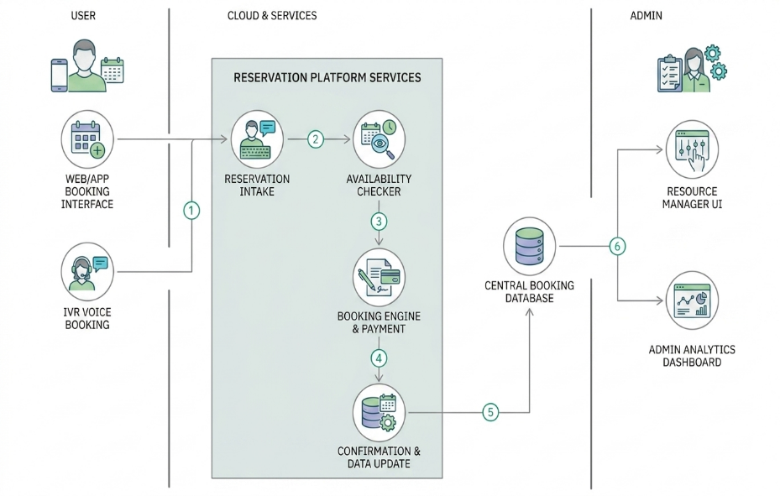
Table-1 : Components & Technologies:
S.No | Component | Description | Technology
 | User Interface | Responsive web booking dashboard for court schedules, profile registration, and equipment rental requests. | HTML5, CSS3, JavaScript, AngularJS, Bootstrap (ServiceNow Service Portal Framework)
 | Application Logic-1 | Core validation logic, conflict checks, multi-court schedule mapping, and automated time-slot release rules. | ServiceNow JavaScript API, Server-Side Business Rules, Script Includes
 | Application Logic-2 | Visual workflow logic to manage email notifications, waitlist queues, and administrative multi-hour booking approvals. | ServiceNow Flow Designer, Workflow Engine
 | Application Logic-3 | Mobile integration module allowing on-the-go slot checking, instant ticket checking, and push alerts | ServiceNow Now Mobile / Agent App Engine
 | Database | Relational custom data model containing tables for court configurations, booking records, and equipment slots. | ServiceNow Custom Tables (u_sports_hall_booking, u_court_config)
 | Cloud Database | Fully managed, high-performance cloud database infrastructure handling system states and secure transaction logs. | ServiceNow Advanced High Availability (AHA) Multi-instance MySQL Architecture
 | File Storage | Repository for facility image maps, system user avatars, and digitized terms/conditions attachment forms. | ServiceNow Document Management & Attachment Storage (sys_attachment)
 | External API-1 | Identity mapping for quick single-sign-on (SSO) login options through enterprise or public identity networks. | Google OAuth 2.0 API, LinkedIn Sign-In API
 | External API-2 | Automated generation and transmission of time-sensitive One-Time Passwords (OTP) for registration validation | Twilio SMS API / ServiceNow IntegrationHub
 | Machine Learning Model | Smart engine predicting peak facility usage hours and suggesting optimal scheduling windows to users. | ServiceNow Predictive Intelligence (Classification / Clustering API)
 | Infrastructure (Server / Cloud) | Managed multi-instance PaaS model providing complete isolation, patching, and data segregation | ServiceNow Enterprise Cloud Infrastructure

Table-2: Application Characteristics:
S. No | Characteristics | Description | Technology
 | Open-Source Frameworks | Frontend component building, dynamic responsive templates, and data rendering utilities. | AngularJS, Bootstrap CSS, Font Awesome Icon Library
 | Security Implementations | Protection of platform tables, automated single-sign-on identity control, and continuous transaction threat prevention. | Role-Based Access Control (RBAC), ACLs, HTTPS/TLS 1.3, Multi-Factor Authentication (MFA), SAML 2.0
 | Scalable Architecture | Multi-tier cloud platform application isolating UI modifications from deep transactional scheduling calculation | Service-Oriented Architecture (SOA), ServiceNow Scoped Application Model
 | Availability | Resilient disaster prevention using synchronized secondary servers to maintain uptime across regions. | Advanced High Availability (AHA) Architecture, Active-Active Data Replication
 | Performance | Fast form loading, fast calendar asset fetching, and optimized query execution via data indexing | ServiceNow Edge Encryption, Browser Cache Control, System DB Indexing, CDN Integration

References:
C4 Model Framework.
AWS Architecture Center.
IBM Cloud Architecture Repository.
Twilio API Documentation
Stripe API Documentation.
Medium System Diagrams.

